Лабораторная работа №8
Тема: «Применение отладочных классов в проекте»

Цель: научиться применять отладочные классы в процессе разработки программного обеспечения для эффективного поиска и устранения ошибок, а также повышения качества и надежности проекта.

Ход работы

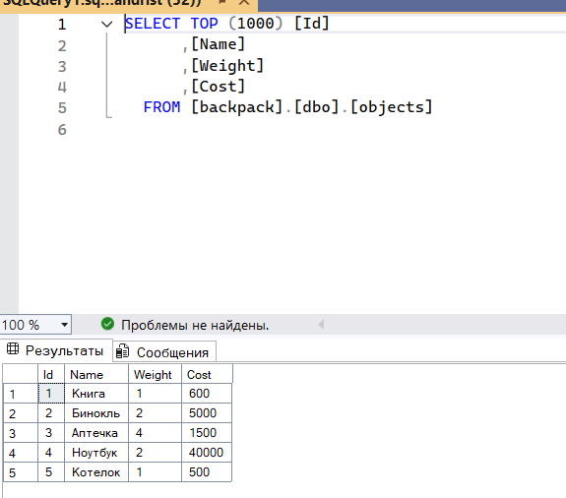
Рисунок 1 - Записи в таблице objects
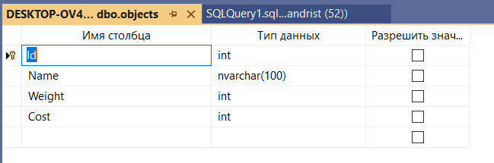
Рисунок 2 – Конструктор таблицы objects
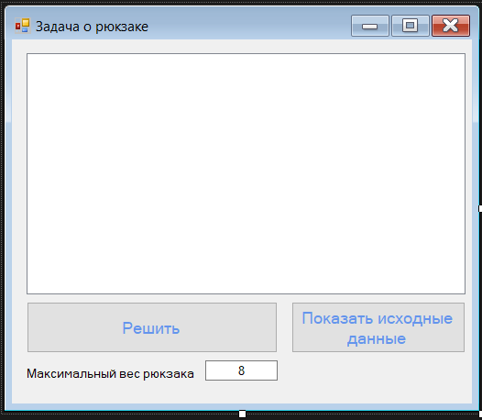
Рисунок 3 – Макет формы Form1.cs
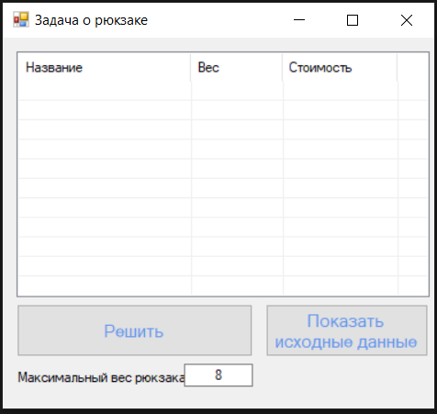
Рисунок 4 – Запуск программы
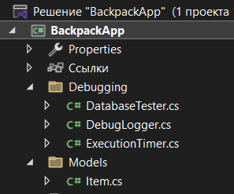
Рисунок 5 – Обозреватель решений проекта
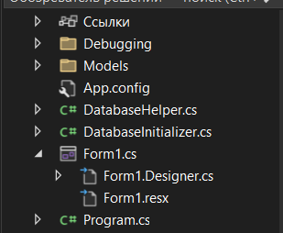
Рисунок 6 – Обозреватель решений проекта
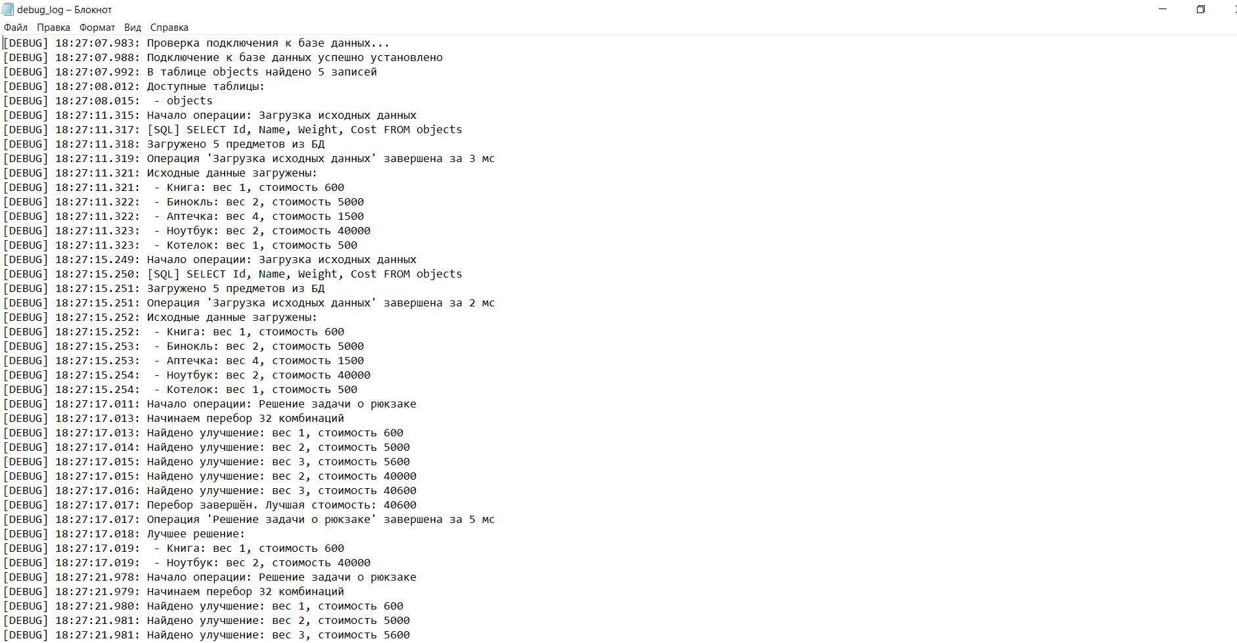
Рисунок 7 – Debug log

ПРИЛОЖЕНИЕ А
Код формы Form1.cs
using BackpackApp.Debugging;
using BackpackApp.Models;
using System;
using System.Collections.Generic;
using System.Windows.Forms;
using static System.Windows.Forms.VisualStyles.VisualStyleElement;

namespace BackpackApp
{
public partial class Form1 : Form
{
private List<Item> _sourceItems;
private List<Item> _bestSolution;

public Form1()
{
InitializeComponent();
SetupListView();
}

private void SetupListView()
{
listView1.View = View.Details;
listView1.FullRowSelect = true;
listView1.GridLines = true;
listView1.Columns.Add("Название", 150);
listView1.Columns.Add("Вес", 80);
listView1.Columns.Add("Стоимость", 100);
}

private void Form1_Load(object sender, EventArgs e)
{
DatabaseInitializer.Initialize();
DatabaseTester.TestConnection();
}

private void btnShowSource_Click(object sender, EventArgs e)
{
try
{
using (new ExecutionTimer("Загрузка исходных данных"))
{
_sourceItems = DatabaseHelper.GetAllItems();
}

DisplayItems(_sourceItems);
DebugLogger.LogItems(_sourceItems, "Исходные данные загружены");
}
catch (Exception ex)
{
MessageBox.Show($"Ошибка загрузки данных: {ex.Message}", "Ошибка",
MessageBoxButtons.OK, MessageBoxIcon.Error);
DebugLogger.Log($"Исключение: {ex}");
}
}

private void btnSolve_Click(object sender, EventArgs e)
{
if (_sourceItems == null || _sourceItems.Count == 0)
{
MessageBox.Show("Сначала загрузите исходные данные.", "Предупреждение",
MessageBoxButtons.OK, MessageBoxIcon.Warning);
return;
}

if (!int.TryParse(txtMaxWeight.Text, out int maxWeight) || maxWeight <= 0)
{
MessageBox.Show("Введите корректный положительный вес рюкзака.", "Ошибка ввода",
MessageBoxButtons.OK, MessageBoxIcon.Error);
return;
}

try
{
using (new ExecutionTimer("Решение задачи о рюкзаке"))
{
SolveKnapsack(maxWeight);
}

if (_bestSolution != null && _bestSolution.Count > 0)
{
DisplayItems(_bestSolution);
DebugLogger.LogItems(_bestSolution, "Лучшее решение");
}
else
{
listView1.Items.Clear();
MessageBox.Show("Не удалось подобрать набор предметов.", "Результат",
MessageBoxButtons.OK, MessageBoxIcon.Information);
}
}
catch (Exception ex)
{
MessageBox.Show($"Ошибка при решении: {ex.Message}", "Ошибка",
MessageBoxButtons.OK, MessageBoxIcon.Error);
DebugLogger.Log($"Исключение в Solve: {ex}");
}
}

private void SolveKnapsack(int maxWeight)
{
int n = _sourceItems.Count;
int bestCost = 0;
List<Item> bestCombination = new List<Item>();

int totalCombinations = 1 << n;
DebugLogger.Log($"Начинаем перебор {totalCombinations} комбинаций");

for (int mask = 0; mask < totalCombinations; mask++)
{
int totalWeight = 0;
int totalCost = 0;
List<Item> current = new List<Item>();

for (int i = 0; i < n; i++)
{
if ((mask & (1 << i)) != 0)
{
totalWeight += _sourceItems[i].Weight;
totalCost += _sourceItems[i].Cost;
current.Add(_sourceItems[i]);
}
}

if (totalWeight <= maxWeight && totalCost > bestCost)
{
bestCost = totalCost;
bestCombination = new List<Item>(current);
DebugLogger.Log($"Найдено улучшение: вес {totalWeight}, стоимость {totalCost}");
}
}

_bestSolution = bestCombination;
DebugLogger.Log($"Перебор завершён. Лучшая стоимость: {bestCost}");
}

private void DisplayItems(List<Item> items)
{
listView1.Items.Clear();
foreach (var item in items)
{
var listItem = new ListViewItem(item.Name);
listItem.SubItems.Add(item.Weight.ToString());
listItem.SubItems.Add(item.Cost.ToString());
listView1.Items.Add(listItem);
}
}
}
}

ПРИЛОЖЕНИЕ Б
Дамп БД
USE [master]
GO
/****** Object: Database [backpack] Script Date: 20.03.2026 8:34:26 ******/
CREATE DATABASE [backpack]
CONTAINMENT = NONE
ON PRIMARY
( NAME = N'backpack', FILENAME = N'C:\Program Files\Microsoft SQL Server\MSSQL16.SQLEXPRESS\MSSQL\DATA\backpack.mdf' , SIZE = 8192KB , MAXSIZE = UNLIMITED, FILEGROWTH = 65536KB )
LOG ON
( NAME = N'backpack_log', FILENAME = N'C:\Program Files\Microsoft SQL Server\MSSQL16.SQLEXPRESS\MSSQL\DATA\backpack_log.ldf' , SIZE = 8192KB , MAXSIZE = 2048GB , FILEGROWTH = 65536KB )
WITH CATALOG_COLLATION = DATABASE_DEFAULT, LEDGER = OFF
GO
ALTER DATABASE [backpack] SET COMPATIBILITY_LEVEL = 160
GO
IF (1 = FULLTEXTSERVICEPROPERTY('IsFullTextInstalled'))
begin
EXEC [backpack].[dbo].[sp_fulltext_database] @action = 'enable'
end
GO
ALTER DATABASE [backpack] SET ANSI_NULL_DEFAULT OFF
GO
ALTER DATABASE [backpack] SET ANSI_NULLS OFF
GO
ALTER DATABASE [backpack] SET ANSI_PADDING OFF
GO
ALTER DATABASE [backpack] SET ANSI_WARNINGS OFF
GO
ALTER DATABASE [backpack] SET ARITHABORT OFF
GO
ALTER DATABASE [backpack] SET AUTO_CLOSE ON
GO
ALTER DATABASE [backpack] SET AUTO_SHRINK OFF
GO
ALTER DATABASE [backpack] SET AUTO_UPDATE_STATISTICS ON
GO
ALTER DATABASE [backpack] SET CURSOR_CLOSE_ON_COMMIT OFF
GO
ALTER DATABASE [backpack] SET CURSOR_DEFAULT GLOBAL
GO
ALTER DATABASE [backpack] SET CONCAT_NULL_YIELDS_NULL OFF
GO
ALTER DATABASE [backpack] SET NUMERIC_ROUNDABORT OFF
GO
ALTER DATABASE [backpack] SET QUOTED_IDENTIFIER OFF
GO
ALTER DATABASE [backpack] SET RECURSIVE_TRIGGERS OFF
GO
ALTER DATABASE [backpack] SET ENABLE_BROKER
GO
ALTER DATABASE [backpack] SET AUTO_UPDATE_STATISTICS_ASYNC OFF
GO
ALTER DATABASE [backpack] SET DATE_CORRELATION_OPTIMIZATION OFF
GO
ALTER DATABASE [backpack] SET TRUSTWORTHY OFF
GO
ALTER DATABASE [backpack] SET ALLOW_SNAPSHOT_ISOLATION OFF
GO
ALTER DATABASE [backpack] SET PARAMETERIZATION SIMPLE
GO
ALTER DATABASE [backpack] SET READ_COMMITTED_SNAPSHOT OFF
GO
ALTER DATABASE [backpack] SET HONOR_BROKER_PRIORITY OFF
GO
ALTER DATABASE [backpack] SET RECOVERY SIMPLE
GO
ALTER DATABASE [backpack] SET MULTI_USER
GO
ALTER DATABASE [backpack] SET PAGE_VERIFY CHECKSUM
GO
ALTER DATABASE [backpack] SET DB_CHAINING OFF
GO
ALTER DATABASE [backpack] SET FILESTREAM( NON_TRANSACTED_ACCESS = OFF )
GO
ALTER DATABASE [backpack] SET TARGET_RECOVERY_TIME = 60 SECONDS
GO
ALTER DATABASE [backpack] SET DELAYED_DURABILITY = DISABLED
GO
ALTER DATABASE [backpack] SET ACCELERATED_DATABASE_RECOVERY = OFF
GO
ALTER DATABASE [backpack] SET QUERY_STORE = ON
GO
ALTER DATABASE [backpack] SET QUERY_STORE (OPERATION_MODE = READ_WRITE, CLEANUP_POLICY = (STALE_QUERY_THRESHOLD_DAYS = 30), DATA_FLUSH_INTERVAL_SECONDS = 900, INTERVAL_LENGTH_MINUTES = 60, MAX_STORAGE_SIZE_MB = 1000, QUERY_CAPTURE_MODE = AUTO, SIZE_BASED_CLEANUP_MODE = AUTO, MAX_PLANS_PER_QUERY = 200, WAIT_STATS_CAPTURE_MODE = ON)
GO
USE [backpack]
GO
/****** Object: Table [dbo].[FileOperations] Script Date: 20.03.2026 8:34:26 ******/
SET ANSI_NULLS ON
GO
SET QUOTED_IDENTIFIER ON
GO
CREATE TABLE [dbo].[FileOperations](
[Id] [int] IDENTITY(1,1) NOT NULL,
[FilePath] [nvarchar](500) NULL,
[Content] [nvarchar](max) NULL,
[SymbolCount] [int] NULL,
[OperationType] [nvarchar](50) NULL,
[OperationDate] [datetime] NULL,
PRIMARY KEY CLUSTERED
(
[Id] ASC
)WITH (PAD_INDEX = OFF, STATISTICS_NORECOMPUTE = OFF, IGNORE_DUP_KEY = OFF, ALLOW_ROW_LOCKS = ON, ALLOW_PAGE_LOCKS = ON, OPTIMIZE_FOR_SEQUENTIAL_KEY = OFF) ON [PRIMARY]
) ON [PRIMARY] TEXTIMAGE_ON [PRIMARY]
GO
/****** Object: Table [dbo].[objects] Script Date: 20.03.2026 8:34:26 ******/
SET ANSI_NULLS ON
GO
SET QUOTED_IDENTIFIER ON
GO
CREATE TABLE [dbo].[objects](
[Id] [int] IDENTITY(1,1) NOT NULL,
[Name] [nvarchar](100) NOT NULL,
[Weight] [int] NOT NULL,
[Cost] [int] NOT NULL,
PRIMARY KEY CLUSTERED
(
[Id] ASC
)WITH (PAD_INDEX = OFF, STATISTICS_NORECOMPUTE = OFF, IGNORE_DUP_KEY = OFF, ALLOW_ROW_LOCKS = ON, ALLOW_PAGE_LOCKS = ON, OPTIMIZE_FOR_SEQUENTIAL_KEY = OFF) ON [PRIMARY]
) ON [PRIMARY]
GO
ALTER TABLE [dbo].[FileOperations] ADD DEFAULT (getdate()) FOR [OperationDate]
GO
USE [master]
GO
ALTER DATABASE [backpack] SET READ_WRITE
GO

